|  |  |  |  |  |  |  |  |  |
| --- | --- | --- | --- | --- | --- | --- | --- | --- |
| Type of test | Description | Expected outcome | Actual outcome | Comments | Status | Tested by | Date | Screen shot |
| Acceptance | Testing the main form loads correctly. | The main form loads correctly. | The main form loaded correctly. All information on the main screen was displayed accordingly. | Worked correctly. No further changes needed. | Pass | Zaki | 16/02/21 | Image 1 |
| Acceptance | Testing the admin button works. | When pressed a new form should pop up allowing the user to enter the admin details. | Outcome as expected. When the button was pressed the admin- window came up and displayed all appropriate information. | Worked correctly. No further changes needed. | Pass | Hossam | 18/02/21 | Image 2 |
| Acceptance | Test the admin input. | When inputted the admin login should work and log the user in. | The input boxes allow input but when the button was pressed the system did not allow the user to be logged in. | Did not work correctly.  Further action required to find a solution to this problem. | Fail | Saleh | 18/02/21 | Image 3 |
| Acceptance | Testing the Guest button works. | When pressed a new form should put up allowing the user to enter the Guest details. | Outcome as expected. When the button was pressed the guest -window came up and displayed all appropriate information. | Worked correctly. No further changes needed. | Pass | Luke | 22/02/21 | Image 4 |
| Acceptance | Test the guest input. | When inputted the admin login should work and log the user in. | The input boxes allow input but when the button was pressed the system did not allow the user. to be logged in. | Did not work correctly.  Further action required to find a solution to this problem. | Fail | Zaki | 22/02/21 | Image 5 |
| Acceptance | Testing the registration button. | When pressed a new form should pop up allowing the user to enter their registration details. | Outcome as expected. When the button was pressed the registration -window came up and displayed all appropriate information. | Worked correctly. No further changes needed. | Pass | Kerri-Anne | 25/02/2021 | Image 6 |
| Acceptance | Test the Registration input. | When inputted the registration should be confirmed under the button. | The input boxes allow input and when the button was pressed the system allowed the user to be registered. The user’s details were saved to a file and a text box displaying the success of the registration appeared. | Worked correctly. No further changes needed. | Pass | Kerri-Anne | 25/02/2021 | Image 7&8 |

Image 1:

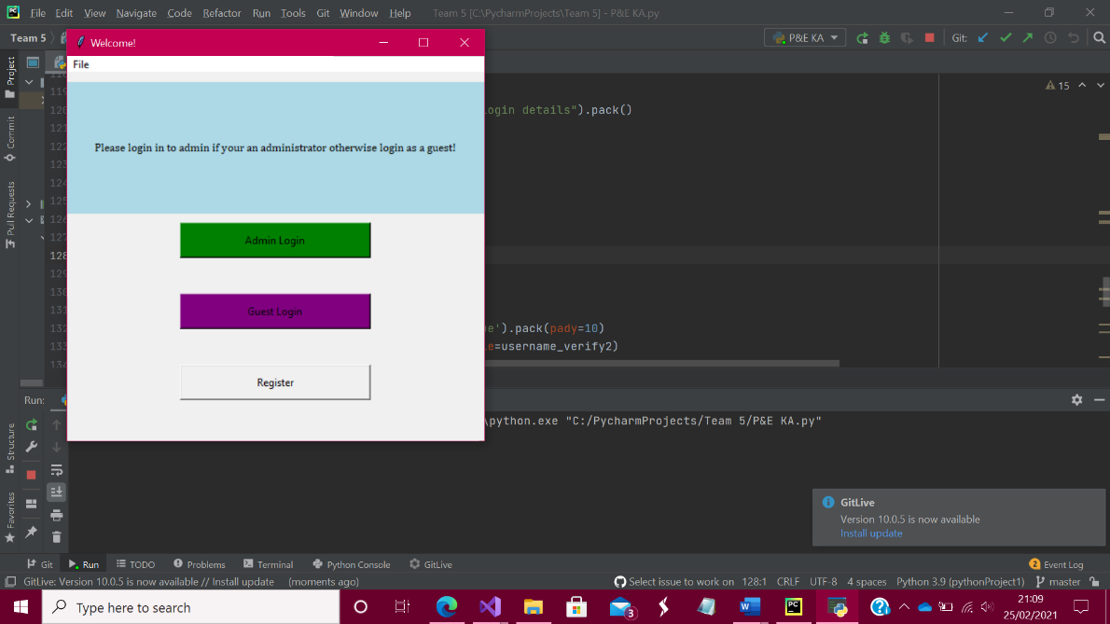

Image 2:

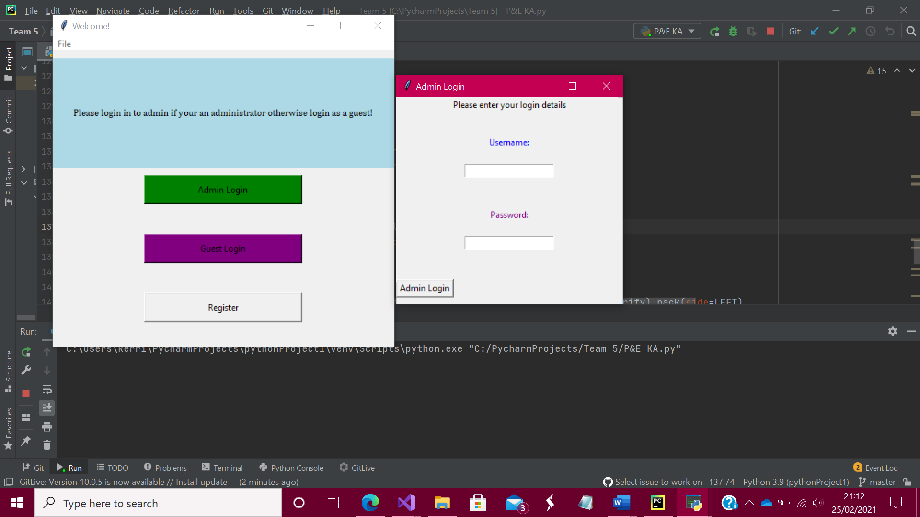

Image 3:

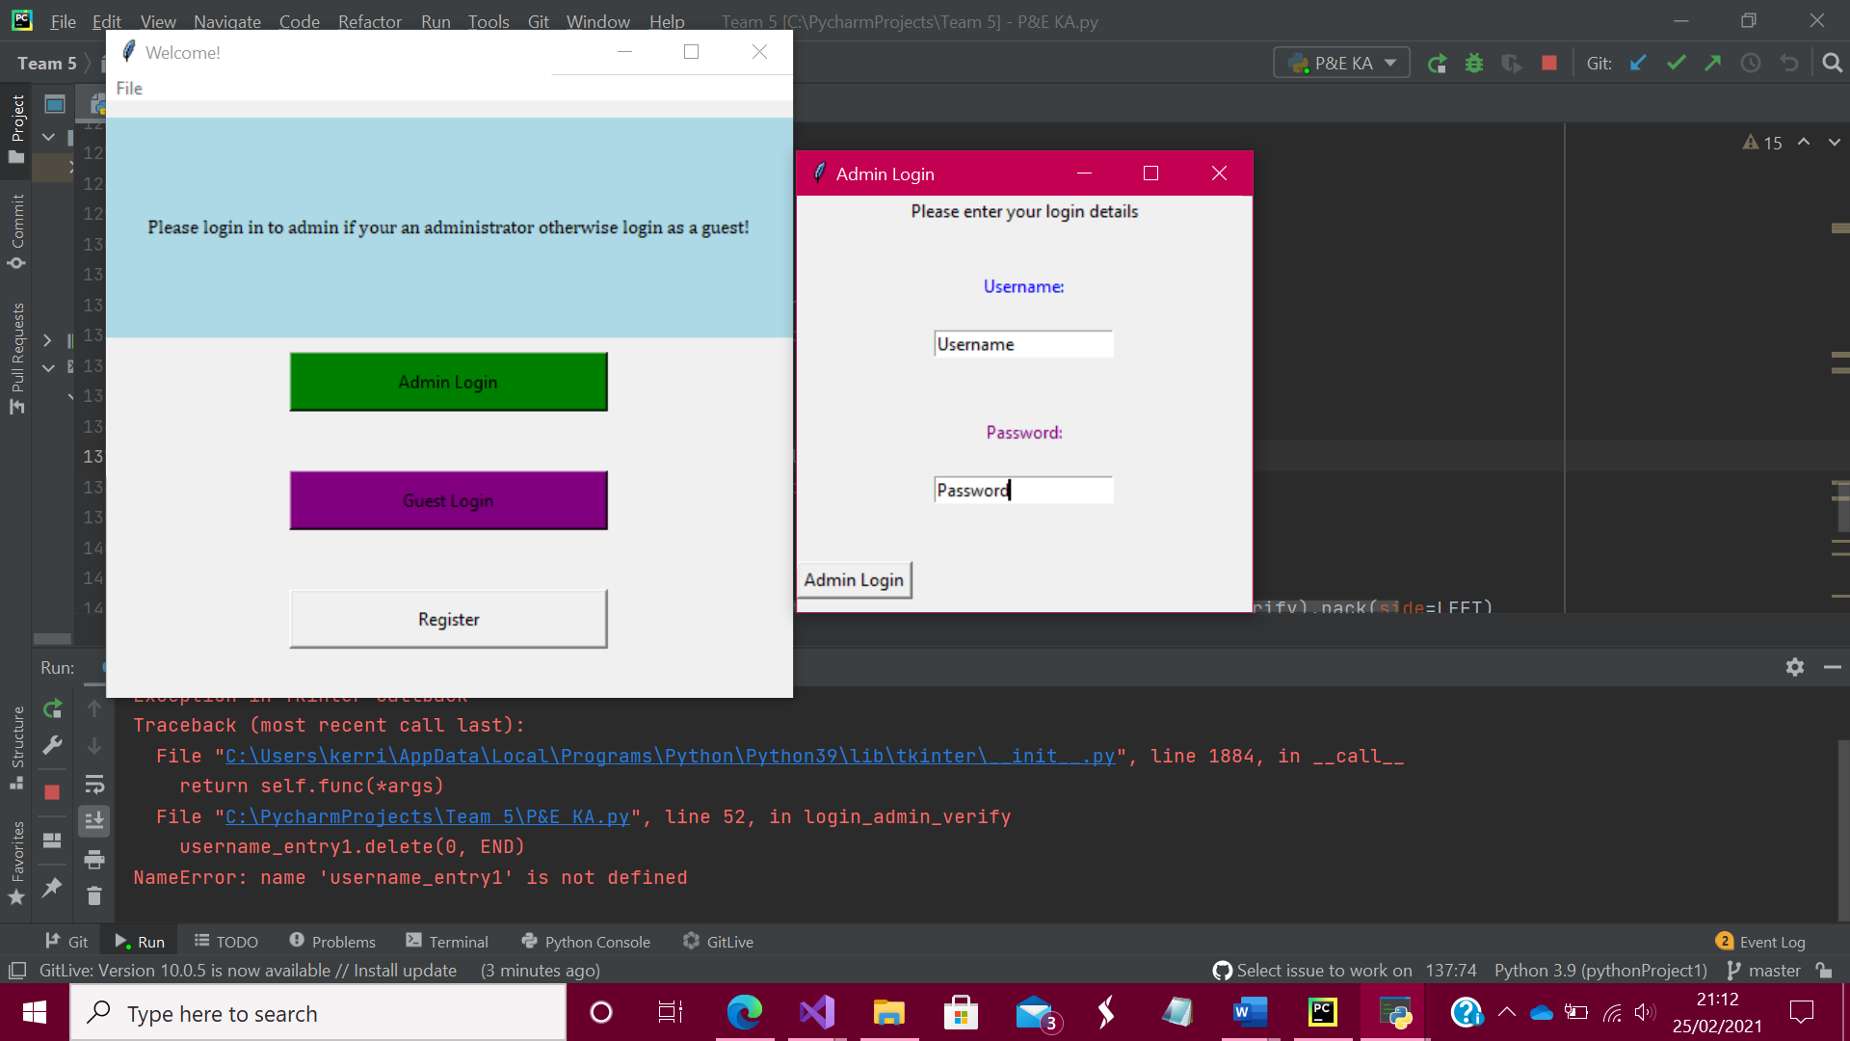

Image 4:

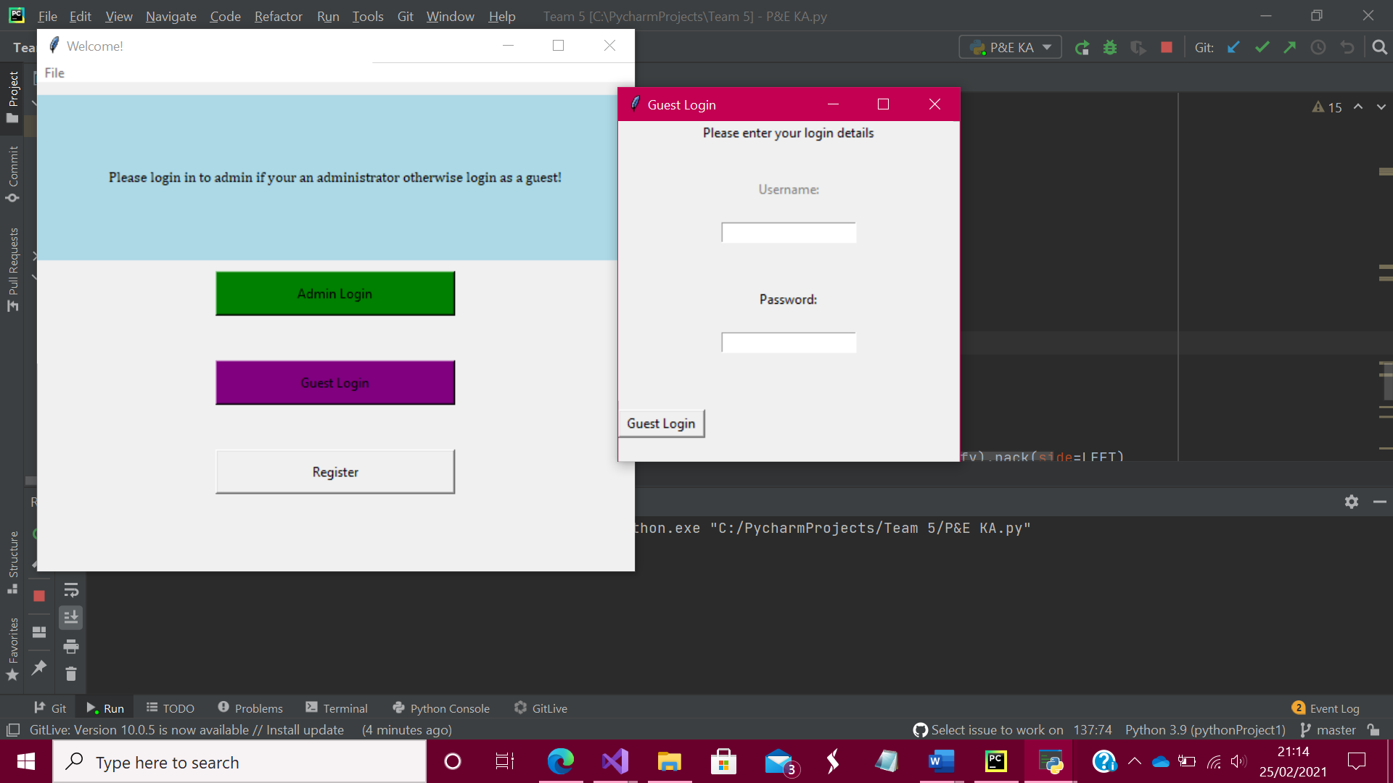

Image 5:

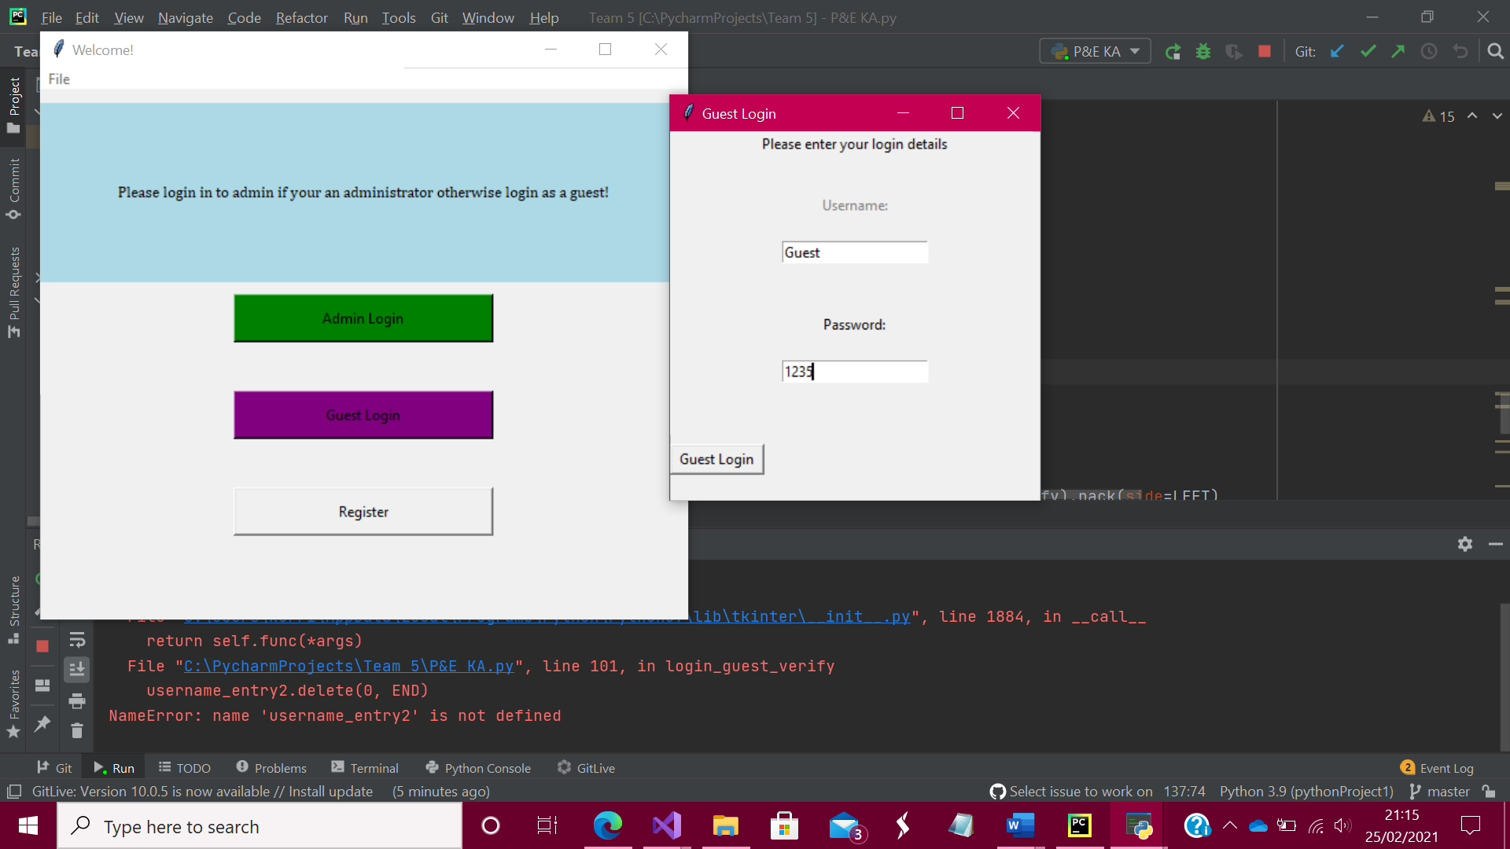

Image 6:

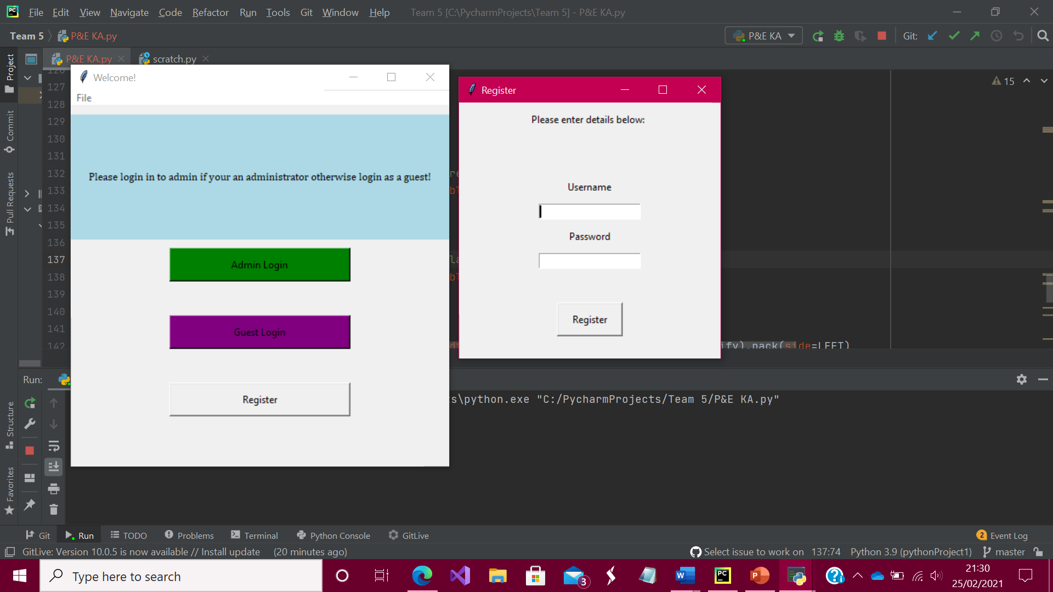

Image 7 & 8:

